## **Segmentation Analysis and Personalization Strategies**

### 

### **Objective:**

Segment stores or departments based on sales patterns, markdowns, and regional features.

Analyze segment-specific trends and characteristics.

Evaluate the effectiveness of the customer segmentation.

Use metrics to assess the quality of segments in terms of homogeneity and separation.

Develop personalized marketing strategies based on the store and department segments.

Propose inventory management strategies tailored to store and department needs.

**Customer segmentation**

Customer segmentation is a critical marketing strategy that involves dividing a customer base into distinct groups based on specific criteria or characteristics.

This practice offers a plethora of benefits for businesses. First and foremost, it enhances customer engagement by allowing companies to tailor their marketing campaigns, messages, and promotions to match the unique needs and preferences of each segment, ultimately boosting customer loyalty and retention.

Moreover, it optimizes product development by providing valuable insights into what different groups of customers are seeking, helping to refine existing offerings or create new ones that cater to these specific needs.

Furthermore, it promotes cost efficiency by focusing resources on the segments most likely to yield high returns, reducing wasted marketing spend.

Personalization becomes possible, strengthening customer relationships, while competitive advantages arise from better understanding and serving segments more effectively than competitors.

Additionally, customer segmentation allows businesses to develop feedback loops, refine strategies, and adapt to evolving customer preferences, enhancing long-term growth prospects.

Cross-selling and upselling opportunities emerge, increasing revenue per customer, while risk mitigation is achieved by diversifying the customer base.

This strategic approach not only fosters sustainable growth but also identifies potential markets for expansion, making it a cornerstone of modern marketing and business success.

**Importance of Customer Segmentation?**

* **Enhanced Customer Retention:** Customer segmentation not only helps in acquiring new customers but also plays a crucial role in retaining existing ones. By tailoring products, services, and communication to the preferences and needs of each segment, businesses can reduce churn rates and build stronger, longer-lasting customer relationships.
* **Refined Pricing Strategies:** Segmentation can inform pricing strategies by identifying which customer segments are price-sensitive and which are willing to pay premium prices for added value. This allows businesses to maximize revenue and profitability.
* **Tailored Customer Support:** Different customer segments may have varying support needs and communication preferences. With segmentation, businesses can provide personalized customer support experiences, leading to higher satisfaction and reduced support costs.
* **Data-Driven Decision Making:** Customer segmentation relies on data analysis, fostering a data-driven culture within an organization. This approach helps businesses make informed decisions across various departments, from marketing and product development to sales and customer service.
* **International Expansion**: For businesses looking to expand into international markets, customer segmentation can help identify cultural, linguistic, and regional differences among customer groups. This knowledge is invaluable for successful global expansion.
* **Effective Inventory Management:** Segmentation can guide inventory management by predicting the demand for different products within each segment. This prevents overstocking or understocking issues and ensures that products are available when and where customers want them.

**Types of Customer Segmentation**

* **Behavioral Segmentation**: Groups customers based on their interactions with the brand, such as website visits, product views, or purchase history.
* **RFM Analysis**: Analyzes Recency, Frequency, and Monetary value of customer transactions to identify high-value segments.
* **Predictive Segmentation**: Uses machine learning algorithms to predict customer behavior and segment customers based on these predictions.
* **Cohort Analysis**: Groups customers who share similar characteristics or experiences, often based on sign-up dates or initial purchase periods.

**Customer Segmentation Algorithms**

* **K-Means Clustering**:
  + Divides customers into K clusters based on their similarity in terms of chosen features (e.g., purchase frequency and amount).
* **Hierarchical Clustering**:
  + Forms a hierarchical tree of clusters, allowing for both broad and fine-grained segmentation.
* **DBSCAN (Density-Based Spatial Clustering of Applications with Noise)**:
  + Identifies clusters based on data density, useful for irregularly shaped clusters.

**Applications and Benefits**

* **Personalized Marketing**: Customer segmentation allows businesses to deliver highly personalized marketing content, messages, and promotions to different segments. This level of personalization increases the likelihood of capturing the attention and interest of each group, resulting in higher conversion rates and customer engagement.
* **Improved Customer Retention**: By identifying and addressing the unique needs and preferences of high-value customer segments, businesses can enhance customer retention. These segments often drive a significant portion of revenue, making it essential to focus on maintaining their loyalty and satisfaction.
* **Enhanced Product Development**: Customer segmentation provides valuable insights into specific customer preferences and pain points. This information can be leveraged to create products that cater to the unique needs of each segment, increasing the likelihood of product success in the market.
* **Reduced Customer Acquisition Costs**: Targeted marketing efforts, made possible through segmentation, can reduce customer acquisition costs. By focusing resources on the most promising customer segments, businesses can optimize their marketing budget and achieve a higher return on investment.
* **Market Expansion Strategies**: Customer segmentation not only helps in serving existing markets but also in identifying opportunities for market expansion. Businesses can use segmentation to analyze untapped markets, adapt their offerings, and enter new geographic regions or customer niches strategically.

I have used the K-Means Clustering algorithm for store and department segmentation.

K-Means Clustering is a popular unsupervised machine learning algorithm used for partitioning data into distinct groups, or clusters, based on similarity. In the context of store and department segmentation, K-Means Clustering offers a powerful approach to identifying meaningful patterns and structures within the data without the need for labeled training examples.

The process of using K-Means Clustering for store and department segmentation typically involves the following steps:

1. **Data Collection and Preprocessing:** The first step is to gather relevant data about stores and departments, including variables such as store size, average weekly sales, consumer price index, and other relevant metrics. The data may come from various sources such as sales records, customer demographics, and inventory data. Once collected, the data is preprocessed to handle missing values, scale numerical features, and encode categorical variables if necessary.
2. **Feature Selection:** After preprocessing the data, the next step is to select the features that will be used for clustering. These features should capture the characteristics that differentiate stores or departments from each other. Common features used for store and department segmentation include store size, sales performance, customer demographics, geographical location, and product assortment.
3. **Determining the Number of Clusters:** One of the key decisions in applying K-Means Clustering is determining the optimal number of clusters (K) to partition the data. This can be done using techniques such as the Elbow Method, Silhouette Score, or Gap Statistics. The goal is to find a value of K that maximizes the homogeneity within clusters while minimizing the heterogeneity between clusters. The optimal number of clusters based on Silhouette score was 4 and we have considered 4 as the optimal number of clusters in K-Means Algorithm.

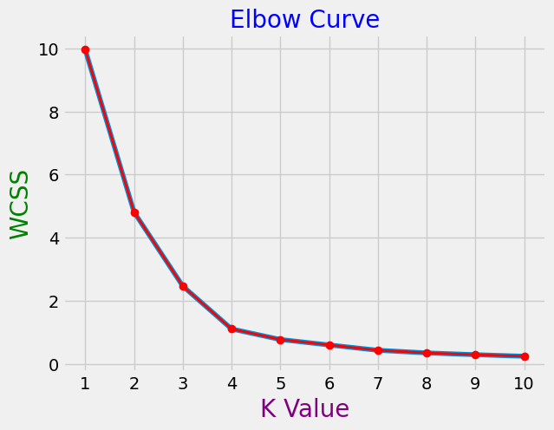

1. **Applying K-Means Clustering:** With the number of clusters determined, the K-Means Clustering algorithm is applied to the preprocessed data. The algorithm iteratively assigns each data point to the nearest cluster centroid and updates the centroids based on the mean of the data points assigned to each cluster. This process continues until convergence, where the centroids no longer change significantly or a maximum number of iterations is reached.
2. **Interpreting Cluster Results:** Once the clustering process is complete, the resulting clusters are interpreted to understand the characteristics and behaviors of the stores or departments within each cluster. This involves analyzing the centroid values and cluster assignments to identify meaningful patterns and insights. Visualizations such as cluster centroids, scatter plots, and heatmaps can aid in interpreting the results and identifying actionable insights.
3. **Segmentation Analysis and Strategy Development:** Finally, the cluster results are used to develop personalized marketing strategies and inventory management strategies tailored to each segment. This involves understanding the unique needs and preferences of customers within each cluster and designing targeted marketing campaigns and inventory management practices to address those needs effectively.

Overall, K-Means Clustering provides a data-driven approach to store and department segmentation, enabling retailers to gain valuable insights into customer behavior, optimize resource allocation, and drive business growth through targeted marketing and inventory management strategies.

# **Segmentation Quality Evaluation:**

Evaluate the effectiveness of the customer segmentation.

Use metrics to assess the quality of segments in terms of homogeneity and separation.

Segment quality evaluation is a crucial step in various data analysis and machine learning tasks, especially in areas like natural language processing (NLP), computer vision, and speech recognition. It helps assess the performance of models or algorithms in dividing data into meaningful segments or clusters. Here, we'll explore several essential metrics and techniques used for evaluating segment quality.

1. **Silhouette Score** 🏞️
   * The Silhouette Score measures how similar an object is to its own cluster compared to other clusters. It ranges from -1 to 1, where higher values indicate better segment quality.
2. **Davies-Bouldin Index** 🗻
   * This index quantifies the average similarity between each cluster and its most similar cluster. Lower values indicate better segmentation.
3. **Inertia (Within-Cluster Sum of Squares)** 🎯
   * Inertia measures the sum of squared distances from each data point to its nearest cluster center. Lower inertia implies better clustering.

In summary, segment quality evaluation is a multifaceted process that requires considering various metrics and techniques. The choice of metrics depends on the specific problem and data characteristics. Using a combination of these metrics can provide a comprehensive assessment of the quality of clustering or segmentation results.

In this project, in order to evaluate the store and department segments I have used a Silhouette score metric to find out the optimal number of clusters.

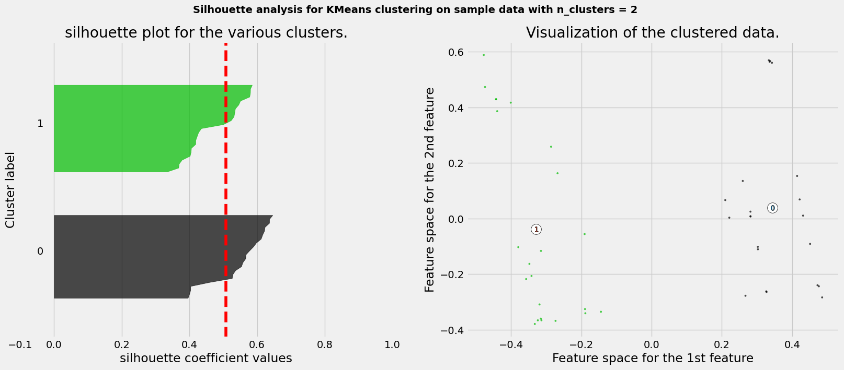

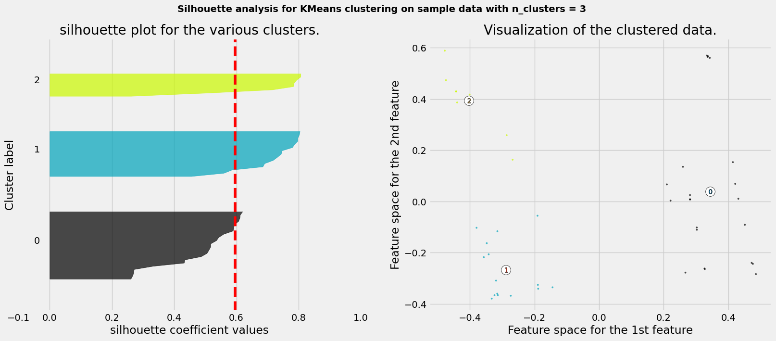

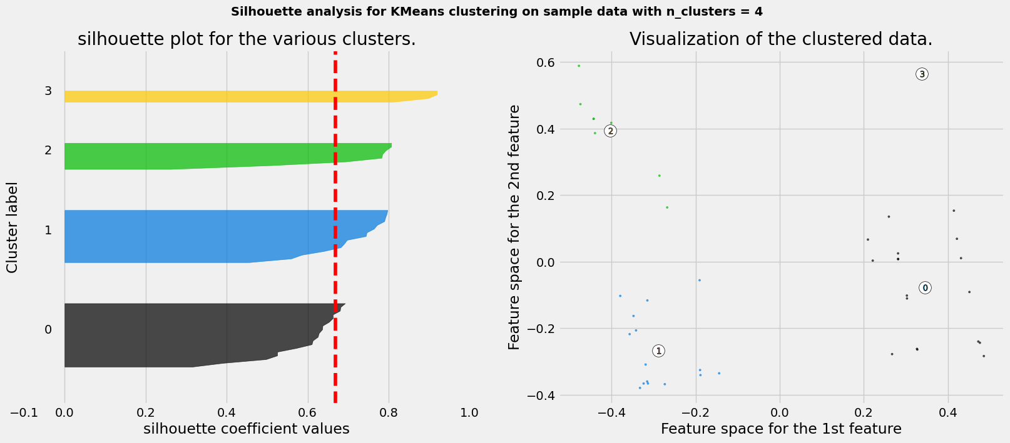

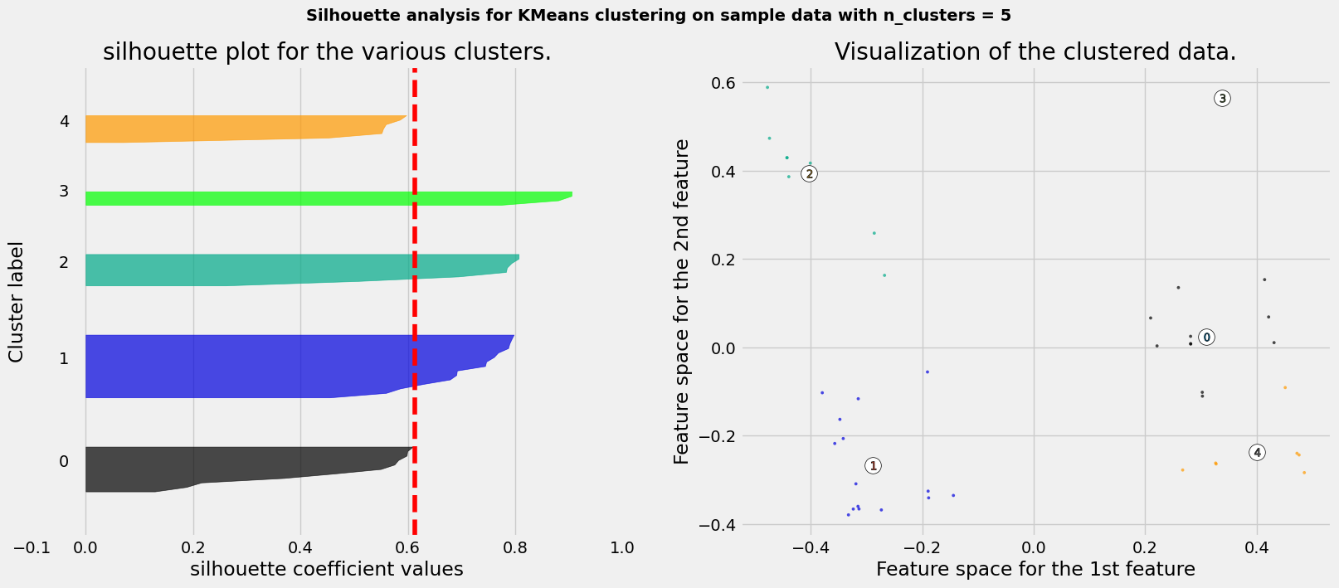

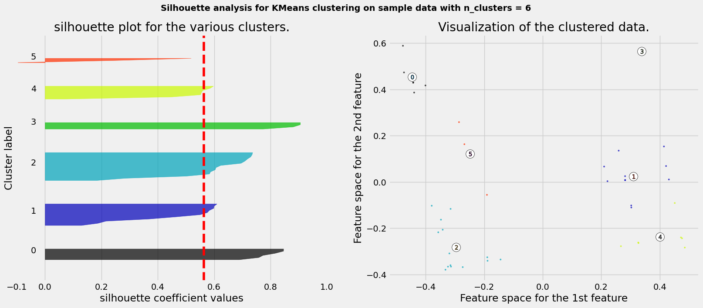

The highest Silhouette score was obtained with a cluster value of 4. Therefore, we have chosen 4 as the optimal cluster value based on the Silhouette score.

**Personalization with Segments**

* Develop personalized marketing strategies based on the store and department segments.
* Propose inventory management strategies tailored to store and department needs.

The learning objective of "Personalization with Customer Segments" is centered on the art and science of tailoring experiences, recommendations, and solutions to distinct groups of customers. In a dynamic business landscape, understanding customer segmentation and harnessing its potential is crucial. This objective delves into the fundamental concepts of customer segmentation, empowering learners to grasp the significance of segmenting audiences based on demographics, behaviors, and preferences. It guides individuals through the process of collecting and preparing data, identifying and labeling customer segments, and designing personalized strategies that cater to each group's unique needs. Moreover, it equips learners with the skills to build custom machine learning models, evaluate their performance within specific segments, and responsibly deploy them in real-world scenarios. By achieving this objective, learners will gain the expertise to drive engagement, conversion rates, and customer satisfaction through the power of personalized experiences, all while staying ethically mindful and attuned to business impact.

## **Store Segmentation Analysis**

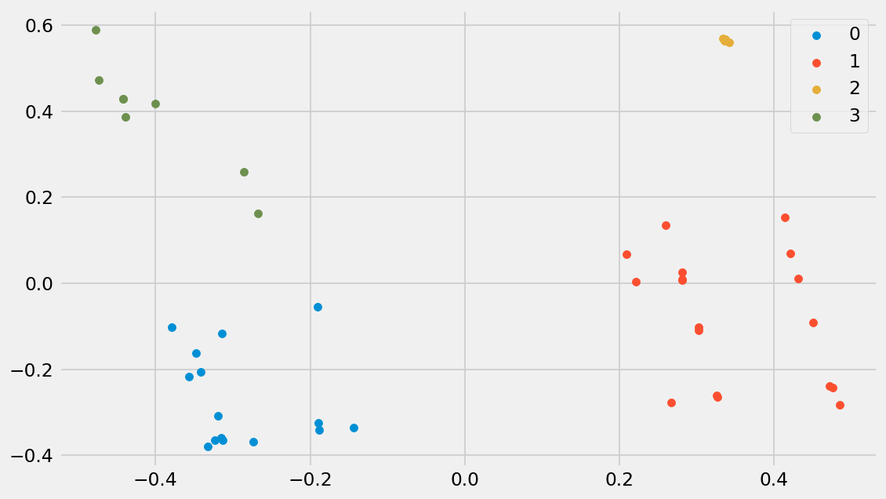

The number of stores per cluster are as follows:-

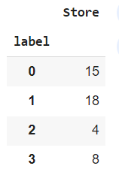

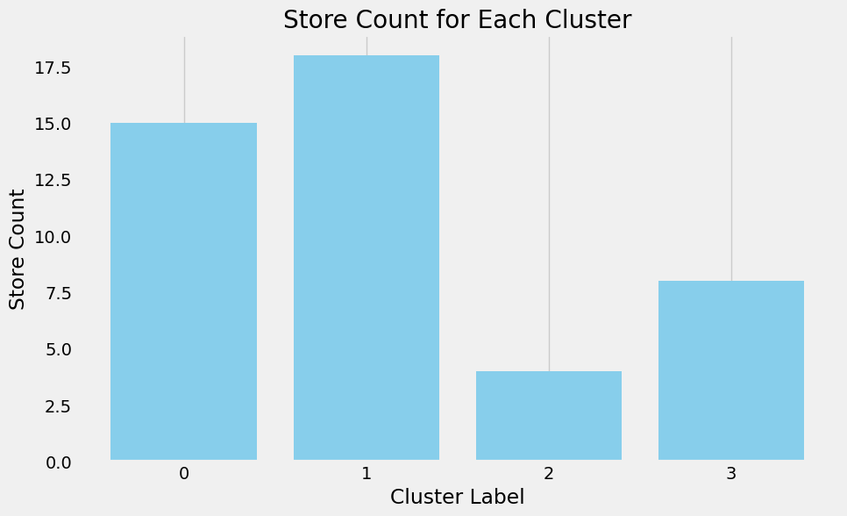

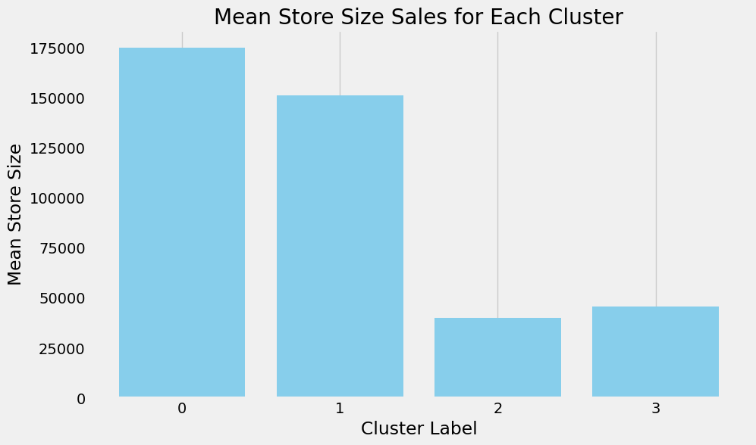

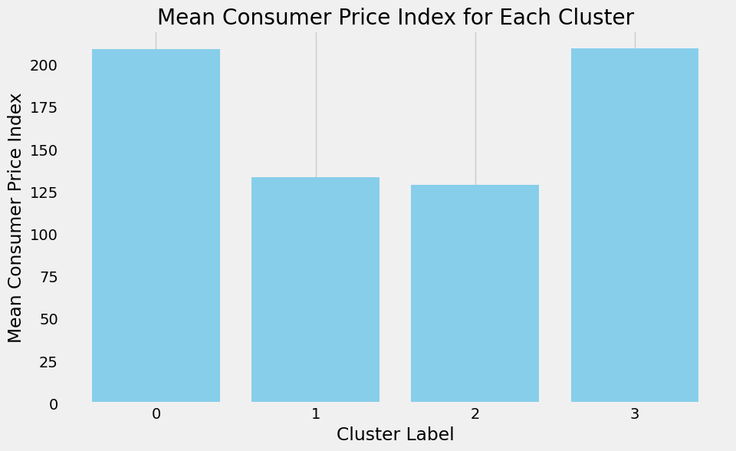

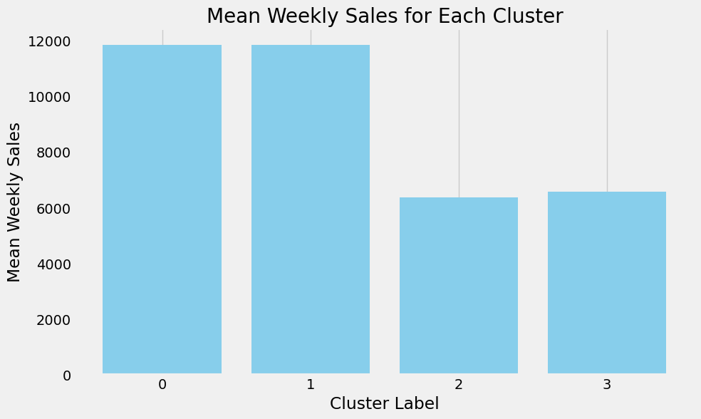

### **Inferences from Store Segmentation Analysis**

**Cluster 0: Premium Space Retailers & Sizeable Luxury Stores**

This cluster consists of stores known for their larger physical footprint and is distinguished by having the highest mean consumer price index among the clusters. The average weekly sales in Cluster 0 stores total 11848, with a total of 15 stores belonging to this group. This cluster can be defined as comprising stores with significant physical space and catering to consumers with higher-priced products.

**Cluster 1: Value-Oriented Stores**

This cluster represents stores with an average weekly sales totaling 11851, with 18 stores in total. It ranks as the second-largest cluster in terms of store sizes and is notable for having the lowest mean consumer price index. Described as comprising stores with medium physical space, it caters to consumers seeking lower-priced products while offering value-oriented shopping experiences.

**Cluster 2: Budget-Friendly Stores**

This cluster represents stores characterized by their lowest average weekly sales, totaling 6362. These stores are notable for their small physical footprint and have the lowest mean consumer price index among the clusters. With a total of 4 stores in this group, it can be defined as comprising stores catering to consumers seeking lower-priced products in compact retail spaces.

**Cluster 3: Compact Elegance Stores**

This cluster encompasses stores known for their smaller physical dimensions and stands out for having a higher mean consumer price index compared to other clusters. The average weekly sales in Cluster 3 stores total 6579, which is relatively lower, with a total of 8 stores belonging to this group.

### **Personalized Marketing Strategies for Store Segments :**

**Cluster 0: Premium Space Retailers & Sizeable Luxury Stores**

Marketing campaigns should highlight the spaciousness and luxury ambiance of the stores.

Emphasize premium product lines and exclusive offerings to attract affluent customers.

Collaborate with high-end brands for co-marketing opportunities to reinforce the store's upscale image.

**Cluster 1: Value-Oriented Stores**

Focus marketing efforts on value-conscious consumers by highlighting competitive pricing and promotions.

Leverage social media platforms and targeted digital advertising to reach budget-conscious shoppers.

Offer loyalty programs and discounts to incentivize repeat purchases and foster customer loyalty.

**Cluster 2: Budget-Friendly Stores**

Promote budget-friendly product lines and emphasize affordability in marketing messaging.

Utilize cost-effective marketing channels such as email campaigns and local advertising.

Highlight deals, discounts, and clearance sales to attract price-sensitive customers.

**Cluster 3: Compact Elegance Stores**

Position the stores as boutique destinations offering curated selections of premium products.

Highlight the elegance and sophistication of the store ambiance in marketing materials.

Target niche market segments such as urban professionals or luxury enthusiasts through personalized outreach and experiential marketing events.

### 

### **Inventory Management Strategies for Store Segments:**

**Cluster 0: Premium Space Retailers & Sizeable Luxury Stores**

Maintain a diverse inventory of high-end products to cater to affluent clientele.

Implement demand forecasting techniques to ensure adequate stock levels of luxury items.

Regularly refresh merchandise to align with changing consumer preferences and trends.

**Cluster 1: Value-Oriented Stores**

Optimize inventory turnover by stocking popular and fast-selling items.

Utilize just-in-time inventory management to minimize excess inventory and reduce storage costs.

Monitor competitor pricing and adjust inventory levels to remain competitive in the value segment.

**Cluster 2: Budget-Friendly Stores**

Focus on lean inventory management practices to minimize carrying costs.

Prioritize stocking essential and high-demand items to maximize sales per square foot.

Negotiate favorable terms with suppliers to secure competitive pricing and maintain margins.

**Cluster 3: Compact Elegance Stores**

Curate a carefully selected inventory of premium products tailored to the tastes of discerning customers.

Implement inventory tracking systems to monitor stock levels and prevent stockouts of high-demand items.

Offer personalized shopping experiences and concierge services to enhance the perceived value of the store's offerings.

## **Department Segmentation Analysis**

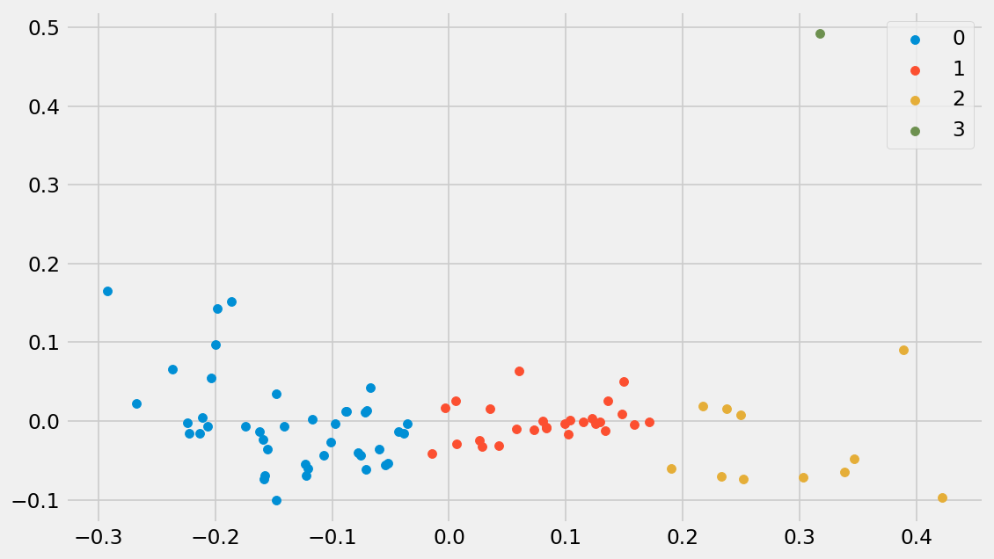

The number of departments per cluster are as follows:-

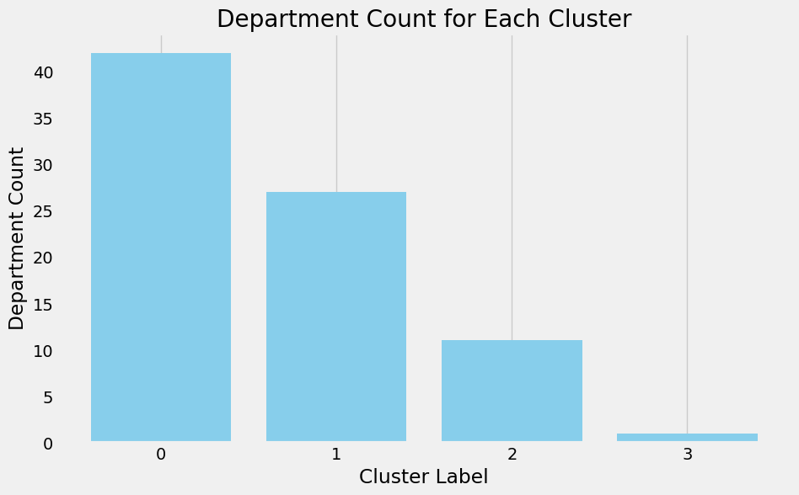

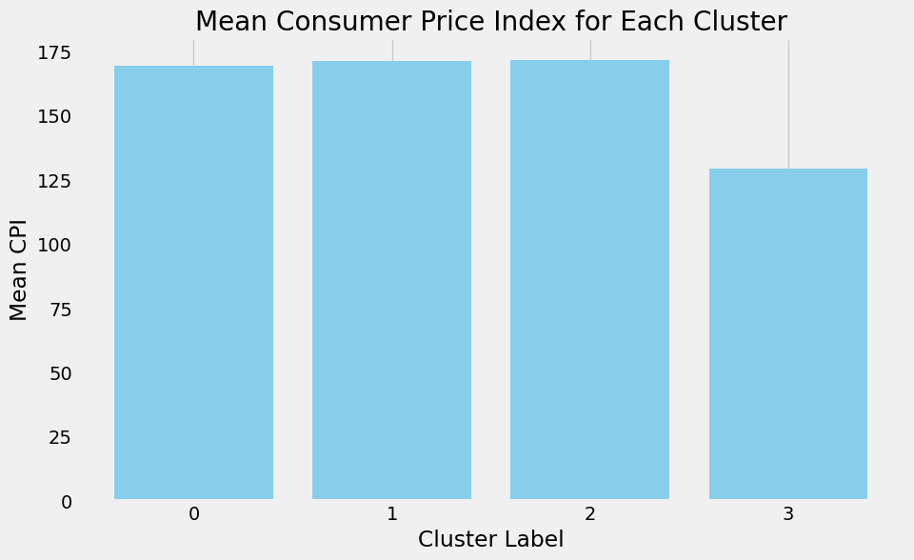

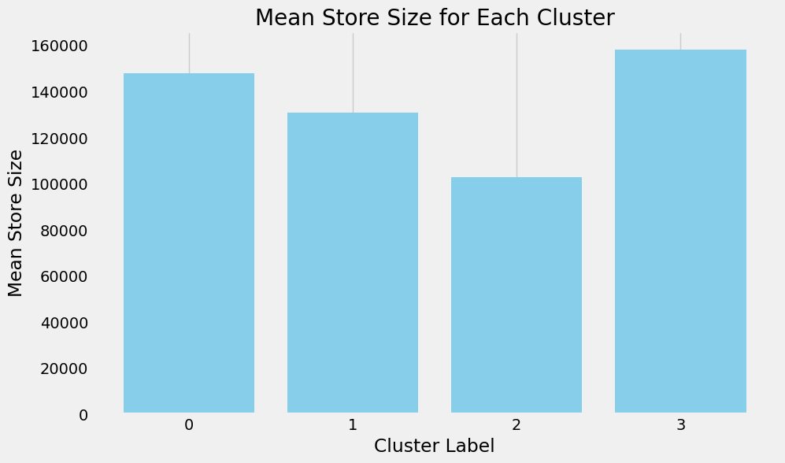

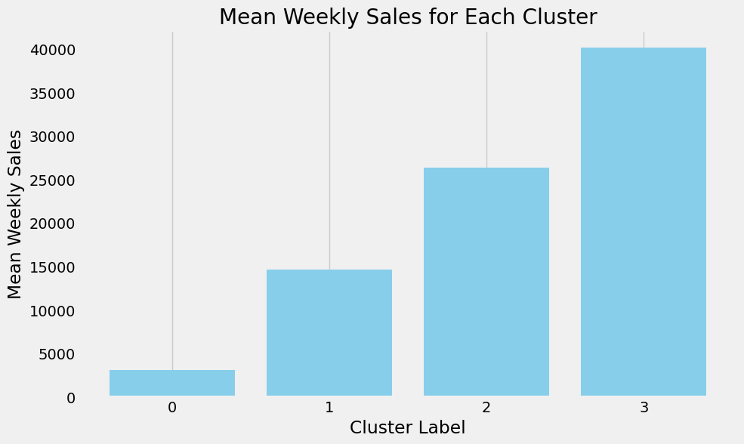

### **Inferences from Department Segmentation Analysis**

**Cluster 0: Sizeable Luxury Departments**

This department cluster comprises stores characterized by their expansive physical space and stands out for having the highest mean consumer price index among the clusters. The average weekly sales in Department Cluster 0 total 3087, with a total of 42 departments belonging to this group. This cluster can be described as encompassing stores with a substantial number of departments, exhibiting dismal mean weekly sales, and catering to consumers with premium-priced products.

**Cluster 1: Premium Selection Departments**

This department cluster consists of stores with an average weekly sales totaling 14,643, spread across 27 departments. It is the third-largest cluster in terms of store sizes and is distinguished by having the highest mean consumer price index. Characterized by medium-sized physical spaces, this cluster caters to consumers who prefer higher-priced products.

**Cluster 2: Elite Departments**

This department cluster consists of departments known for their higher average weekly sales, totaling 26,311. These departments are distinguished by their compact physical footprint and possess the highest mean consumer price index among the clusters. With a total of 11 stores in this group, it can be described as encompassing departments.

**Cluster 3: Grand Outlets Department**

This department cluster comprises departments recognized for their larger physical size and stands out for having a lower mean consumer price index compared to other clusters. The average weekly sales in Cluster 3 departments total 40,165, which is notably high and represents an outlier, with only 1 department belonging to this group.

### **Personalized Marketing Strategies for Department Segments:**

**Cluster 0: Sizeable Luxury Departments**

Highlight the spaciousness and luxury ambiance of the departments in marketing materials.

Promote premium product lines and exclusive offerings to attract affluent customers.

Utilize targeted advertising and collaborations with high-end brands to reinforce the department's upscale image.

**Cluster 1: Premium Selection Departments**

Emphasize the quality and exclusivity of products in marketing campaigns to appeal to discerning customers.

Utilize digital marketing channels and social media platforms to reach a wider audience of luxury shoppers.

Offer personalized shopping experiences and loyalty programs to enhance customer engagement and loyalty.

**Cluster 2: Elite Departments**

Position the departments as boutique destinations offering curated selections of premium products.

Showcase the convenience and efficiency of compact physical spaces in marketing materials.

Leverage influencer partnerships and experiential marketing events to attract high-value customers.

**Cluster 3: Grand Outlets Department**

Emphasize the variety and breadth of products available in the departments to appeal to a wider customer base.

Utilize value-driven marketing messages to highlight affordability and attract price-conscious shoppers.

Implement omnichannel marketing strategies to drive foot traffic to the department while also capitalizing on online sales opportunities.

### **Inventory Management Strategies for Department Segments:**

**Cluster 0: Sizeable Luxury Departments**

Maintain a diverse inventory of high-end products to cater to affluent clientele.

Implement demand forecasting techniques to ensure adequate stock levels of luxury items.

Regularly refresh merchandise to align with changing consumer preferences and trends.

**Cluster 1: Premium Selection Departments**

Optimize inventory turnover by stocking popular and high-margin items.

Utilize just-in-time inventory management to minimize excess inventory and reduce storage costs.

Monitor competitor pricing and adjust inventory levels to remain competitive in the premium segment.

**Cluster 2: Elite Departments**

Focus on lean inventory management practices to minimize carrying costs.

Prioritize stocking essential and high-demand items to maximize sales per square foot.

Negotiate favorable terms with suppliers to secure competitive pricing and maintain margins.

**Cluster 3: Grand Outlets Department**

Implement inventory tracking systems to monitor stock levels and prevent stockouts of high-demand items.

Offer promotions and discounts on slow-moving inventory to stimulate sales and clear excess stock.

Utilize data analytics to identify trends and forecast demand for seasonal and trending products.

#### **Conclusion:**

In conclusion, the customer segmentation and personalized strategies project aimed to segment stores and departments based on sales patterns, markdowns, and regional features, and develop tailored marketing and inventory management strategies. Utilizing the K-Means Clustering algorithm facilitated the segmentation process, with the optimal number of clusters determined based on Silhouette score metrics.

The segmentation analysis revealed distinct clusters within both stores and departments, each characterized by unique sales trends and consumer behaviors. For stores, the clusters ranged from premium luxury retailers to budget-friendly stores, while department clusters spanned from sizable luxury departments to grand outlets. These insights allowed for the development of personalized marketing strategies aimed at targeting specific customer segments, as well as inventory management strategies tailored to the needs of each store or department cluster.

Marketing strategies were tailored to highlight the unique characteristics of each cluster, emphasizing factors such as store ambiance, product assortment, and pricing strategy. For example, premium luxury retailers focused on exclusive offerings and collaborations with high-end brands, while budget-friendly stores emphasized affordability and value-driven promotions. Similarly, inventory management strategies were designed to optimize stock levels and minimize carrying costs based on the sales patterns and consumer preferences within each cluster.

Overall, the project demonstrated the effectiveness of customer segmentation in driving personalized marketing and inventory management strategies. By understanding the distinct needs and behaviors of different customer segments, retailers can better allocate resources, optimize sales, and enhance the overall customer experience. Moving forward, ongoing analysis and refinement of segmentation strategies will be essential to adapt to evolving market dynamics and consumer preferences.